Search and save records from Horizon for printed label purpose

Search for records you need to create labels for in Horizon:
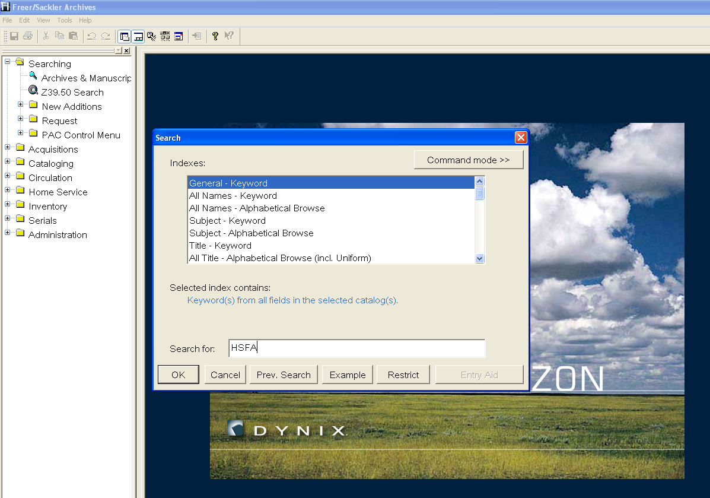

Click to highlight records you need to create labels:
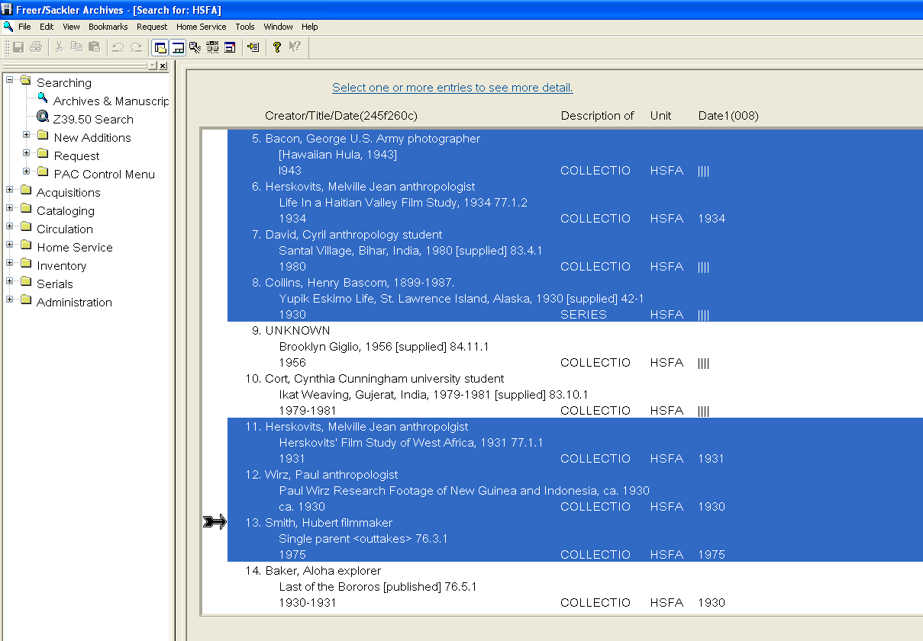

Bookmark the selected record:
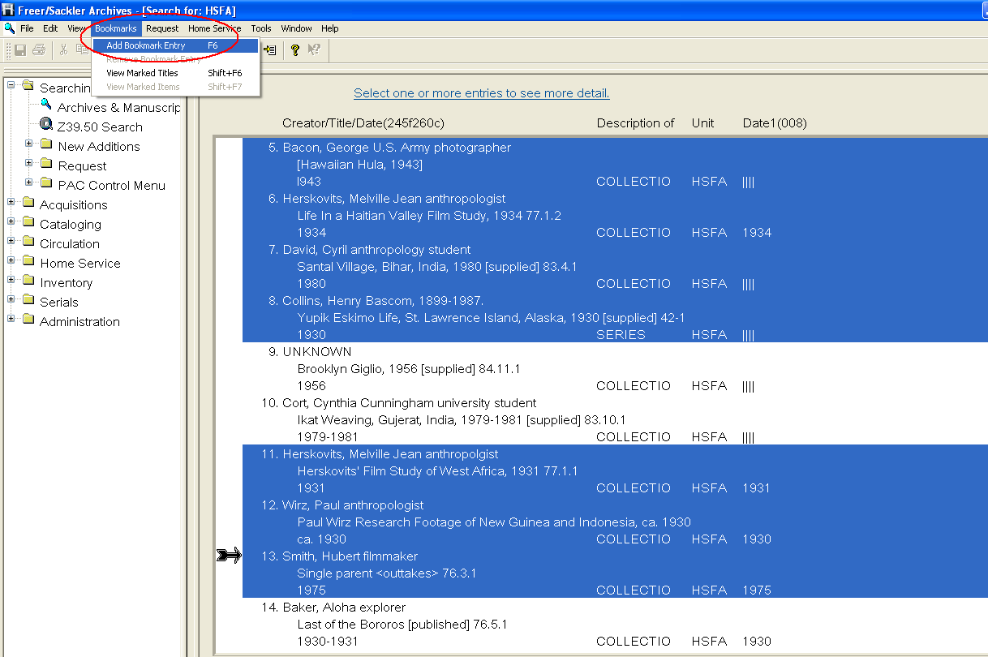

Select title and click on okay:
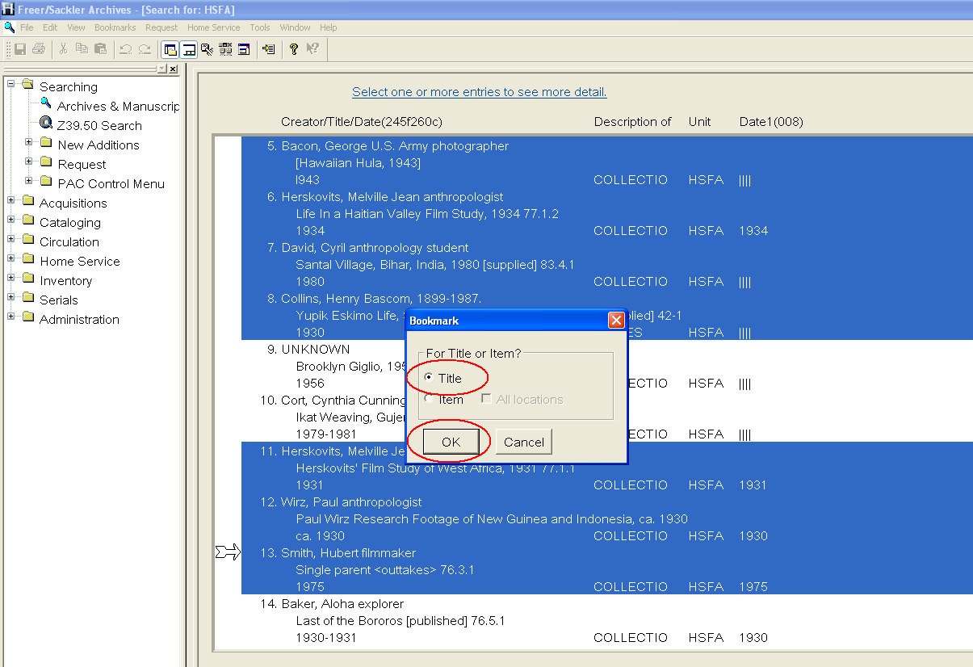

Click OK:
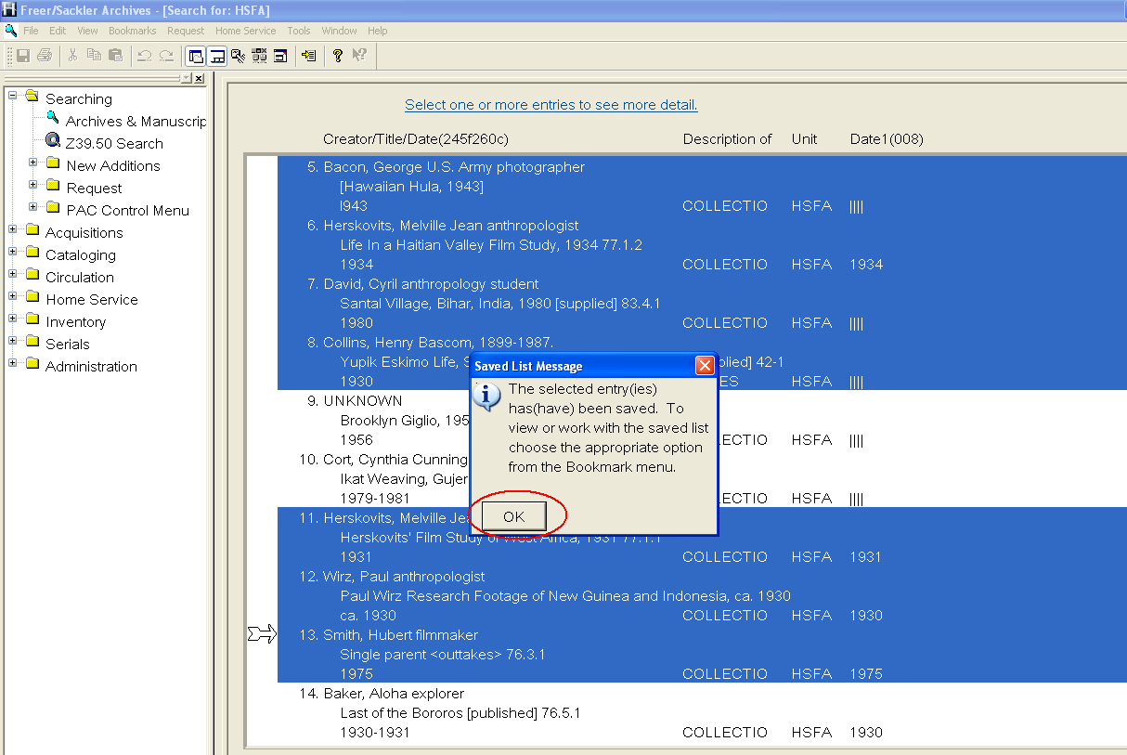

Save the list to a file with the “Brief Title Info” option:
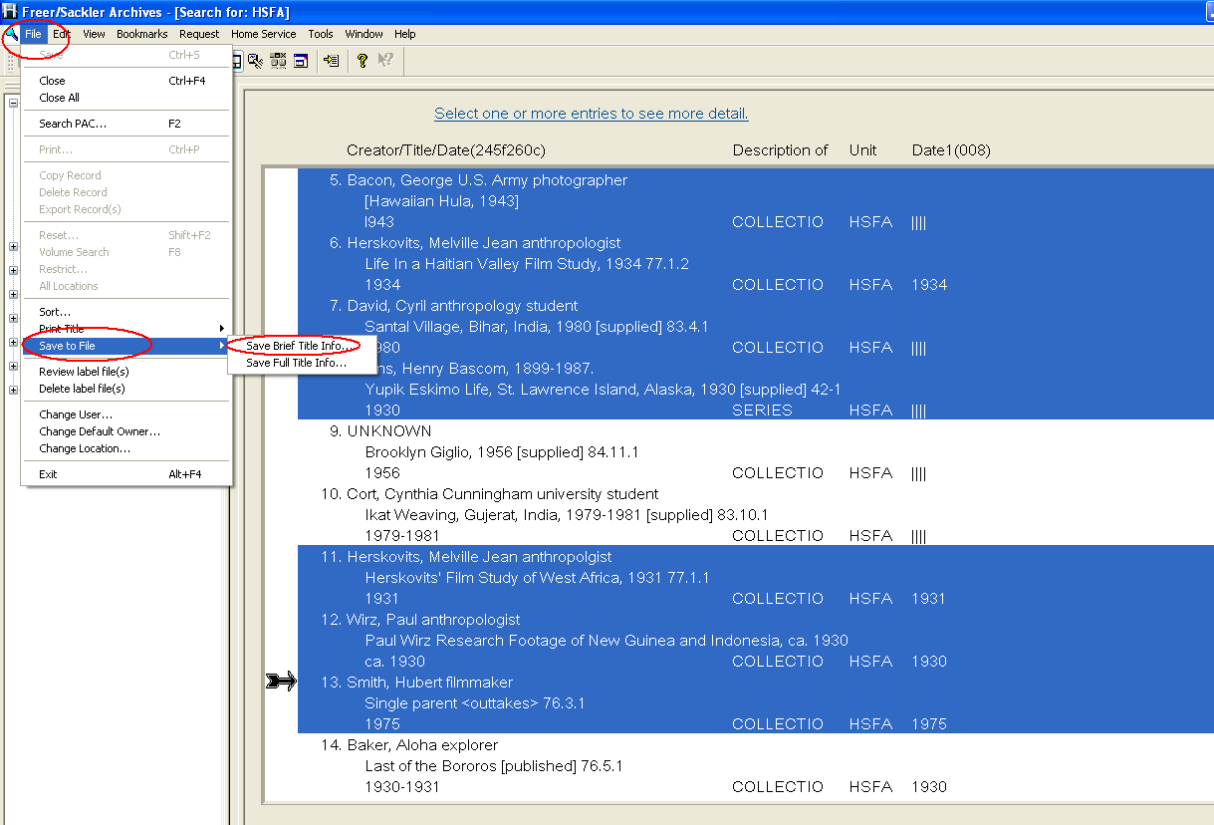

Select a directory, and a file name for the saved list for printing purpose:
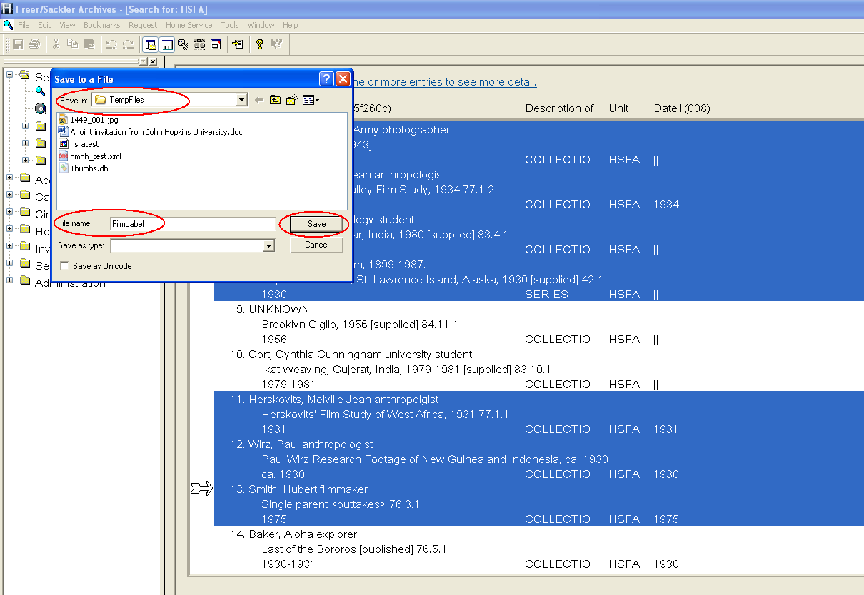

View Mookmarked records:
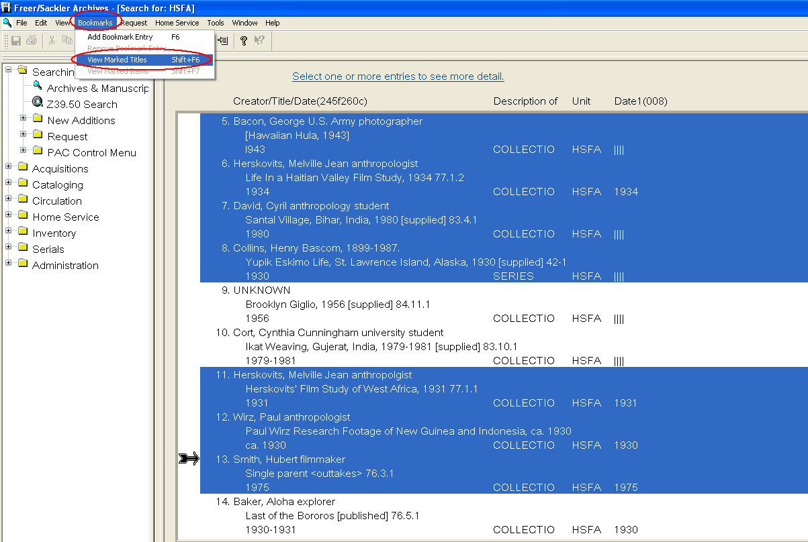

Optional step: sort the list or customize your label display. (you can include, exclude, shorten or lengthen fields for the label layout)
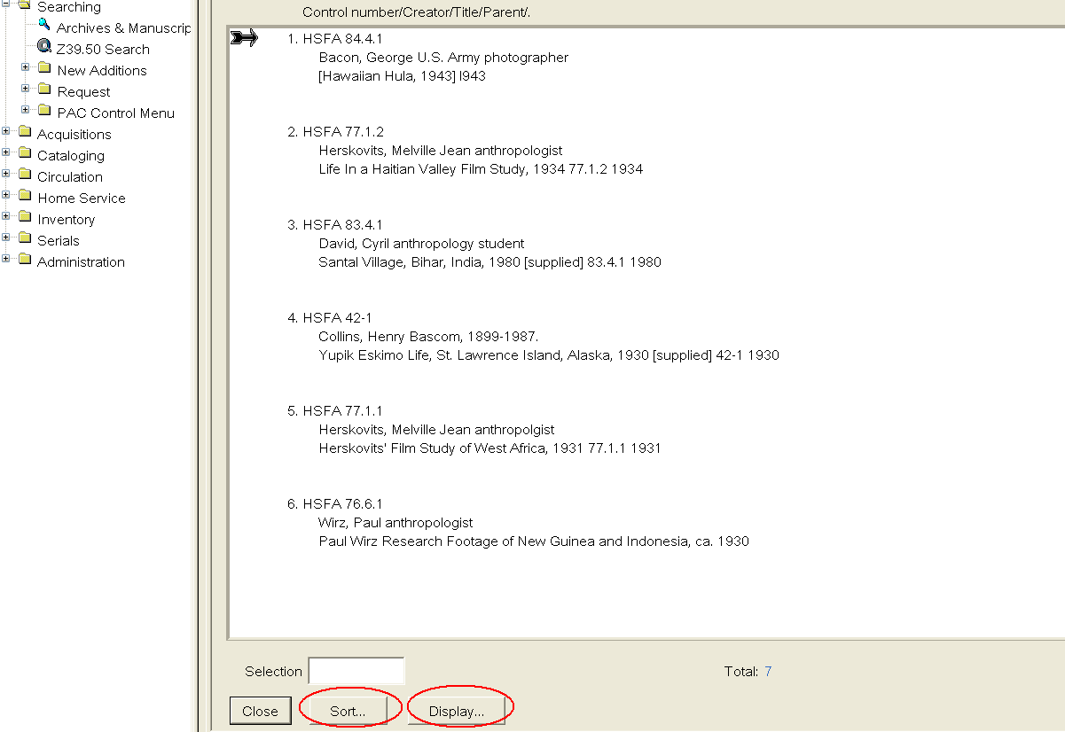

Finally, Your labels are ready to be saved:
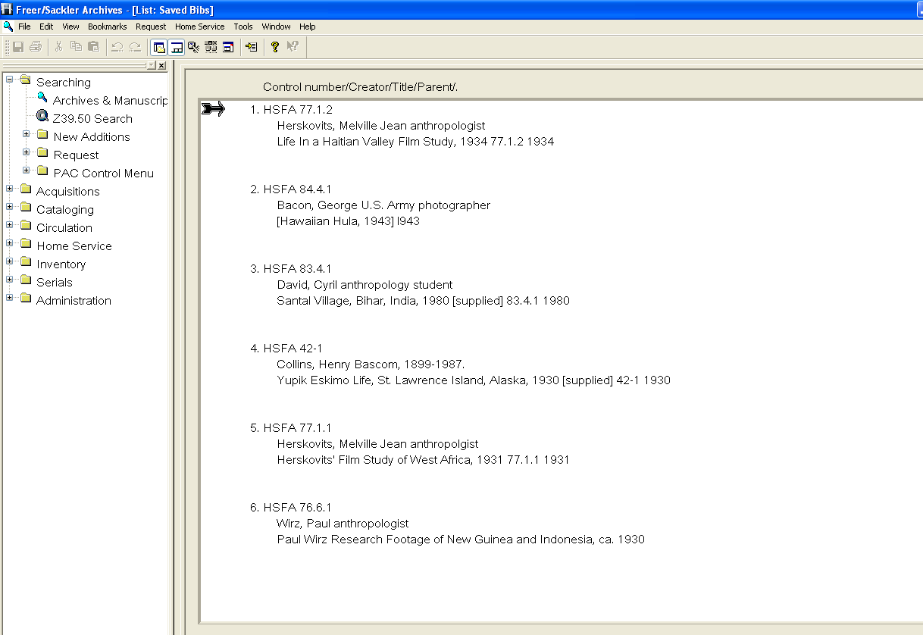

Save the labels with the “brief title info” option:
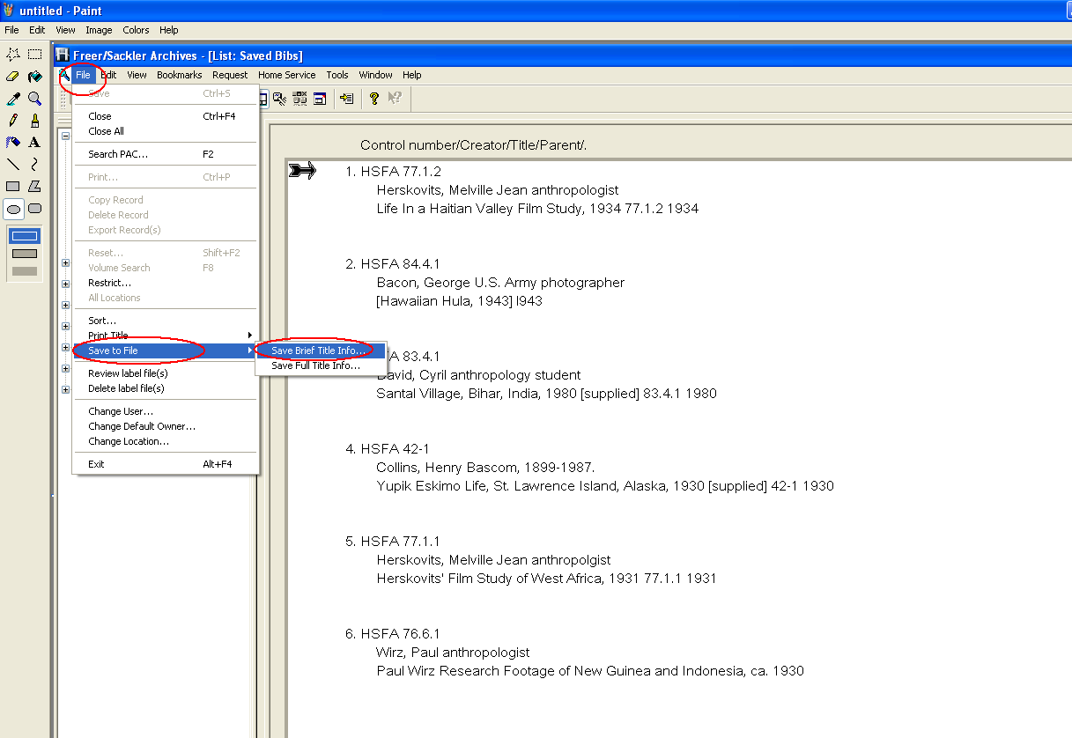

Save the record with your choice of file name and directory:
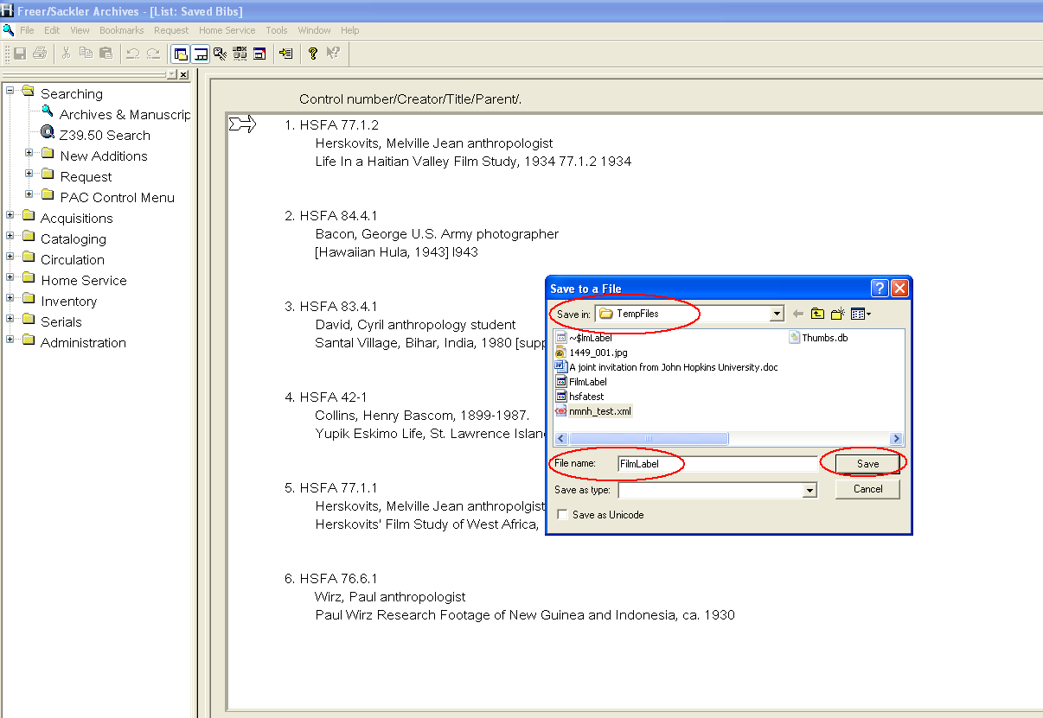

Choose “As displayed” option:
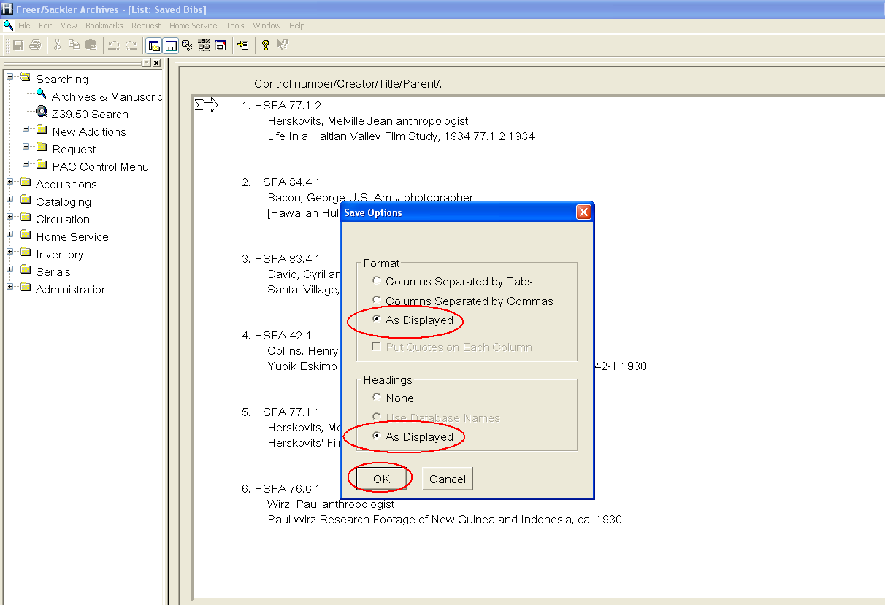

Your label list is now created. Open the file with either MSWord or Notepad software:

